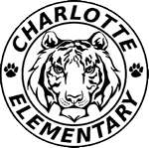
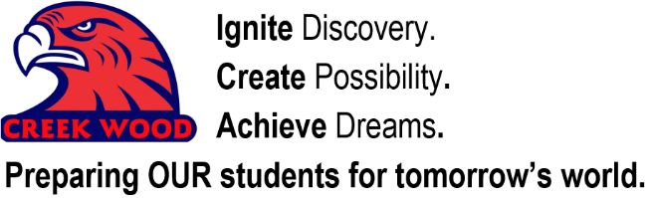
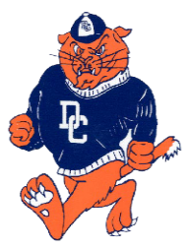

______________________ has been chosen to participate in the Rivalry Rumble (formerly Unity Run) at Creek Wood High School. The Rivalry Rumble brings together CWHS and DCHS in an event to get ready for the CW vs. DC football game. Ten students per grade level have been selected for the Rivalry Rumble. Every elementary school in the county will be participating. There will be an opportunity for OUR school to take home 6 trophies from The RUMBLE. The Rivalry Rumble is on Thursday, August 17th. Students should be at CW before 5:45.
Breakdown of events:

- 5:30 Gates Open
- 6:00 5K starts
- 6:15 Kindergarten Event (Sack Race -10 elementary students from each school)
- 6:30 1st Grade Event (Football Relay/Obstacle Course -10 elementary students from each school)
    - Obstacle course includes running around a cone, through a hula hoop, and around another cone.

- 6:45 2nd Grade Event ( 3-legged race - 10 elementary students from each school)
- 7:00 3rd Grade Event (Hula Hoop Relay -10 elementary students from each school)
- 7:15 4th Grade Event (Bucket Pass Relay -10 elementary students from each school)
    - Big bucket of water at the beginning. Students fill smaller bucket of water and pass to second student over his/her head to next student, that student then passed smaller bucket between legs to 3rd student and the race continues until a bucket at the end of the 10 students is filled.

- 7:30 5th Grade Event (Tug of War -10 elementary students from each school)

- 7:45 Fun Run with Mascots - any elementary students who would like to run a lap
around the track with mascots can participate.

- 8:00 High School Relay between CWHS and DCHS
(Elementary students are encouraged to stay for race to cheer on their future school, but it’s not required)

If your child has a Charlotte Elementary shirt, they should wear it for this event. At the conclusion of each event, a trophy will be awarded for students to take back to their school for the year.

All students are free to the event. Adults are $5.00. Teacher/coaches are free.

Concessions will be available with Hamburgers, Hot Dogs, and Chickens.
Shaved Ice Truck will be at CW!

______ YES, I would like for my child to participate in the Rivalry Rumble on Thursday, August 17th.
I understand that I should have my child at CWHS before 5:45 on Thursday, August 17th.

______ No, my child will not be participating in the Rivalry Rumble.

________________________________ ______________________
Parent Signature Contact #

