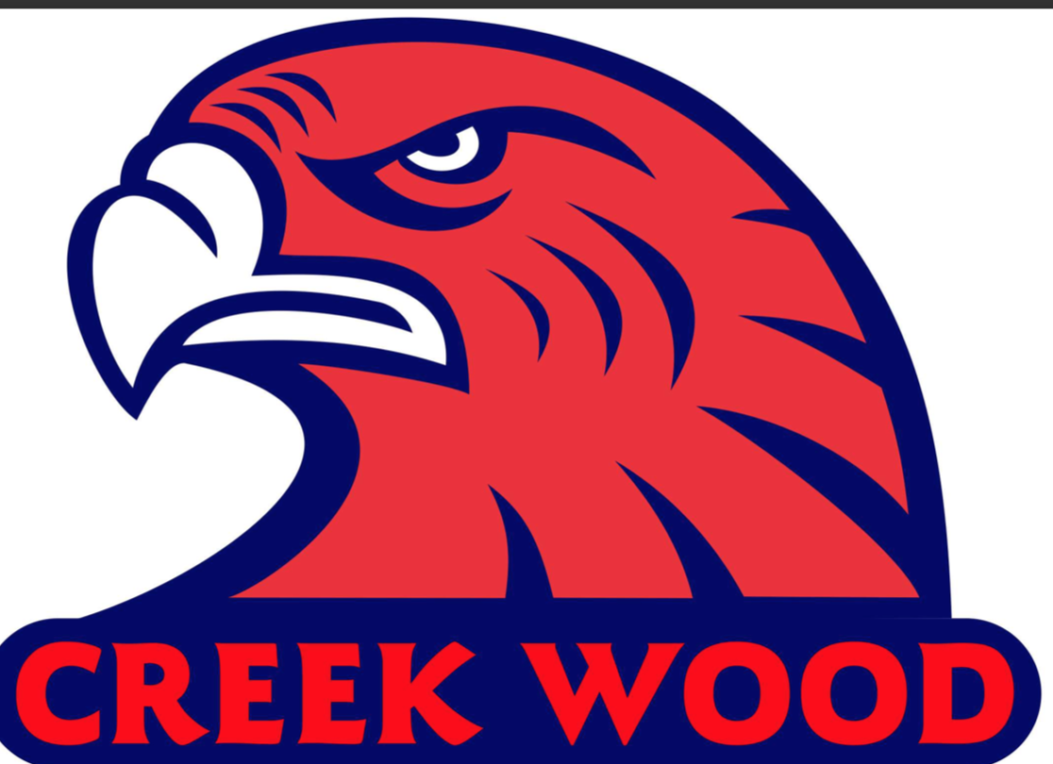
Ignite Discovery.
Create Possibility.
Achieve Dreams.
Preparing OUR students for tomorrow’s world.

Student Dress Expectations 2017-2018

Collared Shirts:
- Button-up or polo shirt of any color/pattern
- Any officially licensed college or university shirt

Non-negotiables for collared shirts – Free from holes, tears, and inappropriate language or inappropriate logos. Must have sleeves.

T-Shirts:

- Any color or pattern t-shirt
- Any CWHS t-shirt, any officially licensed college/university t-shirt, any professional sports team shirt

Non-negotiables for t-shirts – Free from holes, tears, and inappropriate language or inappropriate logos/images. V-neck shirts must be at collar bone. Must have sleeves. No tank tops. No scoop neck shirts. No cleavage.

Blouses:
- Any color or pattern

Non-negotiables for blouses – Free from holes, tears, and inappropriate language or inappropriate logos/images. No lace or sheer material. V-neck shirts must be at collar bone. Must have sleeves (no peephole/cold shoulder shirts). No tank tops. Cannot be backless. No scoop neck shirts. No cleavage.

Pants:
- Any color/pattern pant

Non-negotiables for pants – Free from holes, tears. Must button, zip, and have pockets.
No sweat-pants, athletic pants, yoga pants, tights, leggings, or jeggings.

Shorts/Skirts/Dresses:

- Any color/pattern to the knee

Non-negotiables for shorts/skirts/dresses – Free from holes, tears. No sweat-pants, athletic pants, yoga pants, tights, leggings, or jeggings. Dresses must have appropriate neckline.

Jackets/Sweaters/Sweatshirts:

- Any appropriate pattern
- Any CWHS or officially licensed college or university jacket/sweater/sweatshirt

Non-negotiables for jackets/sweaters/sweatshirts – Free from holes, tears, and inappropriate language or inappropriate logos/images.

Team Warm-Ups:
- Official CWHS team gear/ warm-ups can be worn if entire team is directed by the Head Coach of a particular sport.
Non-negotiables for Team Warm-Ups – Team warm-ups must match and be worn by the entire team. Head Coach of the sport will send an email noting that team issued warm-ups will be worn.

Non-negotiables for CWHS: All clothing must be the proper size/fit, free of any rips/holes/tears and have sleeves. Sweat-pants, yoga pants, tights, leggings, jeggings, pajamas, athletic shorts, tank-tops, hats, house shoes, chains, spikes, lace or sheer material, sunglasses, blankets, animal tails/ears or anything that is deemed inappropriate or distracting will not acceptable. All clothing must be free of any inappropriate language and/or inappropriate images.
Any student dress that disrupts the learning environment is not acceptable.

